DEPARTMENT OF ROBOTICS & ARTIFICIAL INTELLIGENCE

Total Marks: 7.5

Obtained Marks:

Artificial Neural Networks
Lab Project

Last Date of Submission: 20th October, 2026

MomentMind AI: Natural Language Video Moment Retrieval

Submitted To: | Muhammad Hasaan Mujtaba
Student Name: | Jalisha Khalid Ali
Registration Number: | 24108209

DEPARTMENT OF ROBOTICS & ARTIFICIAL INTELLIGENCE

1. Project Overview

MomentMind AI is a natural-language video retrieval system that helps users find visually relevant moments without manually watching an entire video. A user uploads a video, enters a text query describing an action or scene, and receives up to five relevant sampled frames with timestamps and similarity scores.

2. Objectives

- Search video content using ordinary text, such as “a person opens a door.”
- Rank sampled frames according to their similarity to the text query.
- Display the top five matching frames, timestamps, similarity scores, and blur scores.
- Provide an estimated time window around the best-matching frame.
- Run the application as a local website on a Windows computer.

3. Technologies Used

Technology | Purpose
Python | Main programming language and application logic
Google Colab | Development and GPU-based experimentation
PyTorch + Transformers | Loading and running the pretrained CLIP model
CLIP (openai/clip-vit-base-patch32) | Comparing text descriptions with video frames
OpenCV | Reading videos, sampling frames, and calculating blur scores
Flask | Backend web application and upload handling
HTML / CSS | Website structure and visual design

DEPARTMENT OF ROBOTICS & ARTIFICIAL INTELLIGENCE

4. System Workflow

- The user uploads a supported video through the website.
- OpenCV reads the video and samples a frame approximately every 0.5 seconds.
- The sampled frames are prepared as images for CLIP.
- The text query is evaluated in three forms: the original query and two descriptive prompt variations.
- CLIP calculates text-image similarity scores for the sampled frames.
- The frames are ranked, and up to five top results are selected.
- The website displays matching frames, timestamps, scores, and a short report.

5. Main Features

- Natural-language search for actions and scenes.
- Top-five matching-frame gallery with timestamps and similarity scores.
- Approximate time window around the best-ranked frame.
- Blur analysis using variance of the Laplacian, with a rough low-clarity indicator.
- Flask website with custom HTML/CSS styling.
- Windows launcher (run_windows.bat) to help install dependencies and start the app.
6. Implementation

Development began in Google Colab, where the pretrained CLIP model was loaded and tested on an uploaded video. OpenCV extracted frames at 0.5-second intervals and calculated a blur score for each frame. A text query was compared with the sampled images, and the highest-scoring frames were displayed. A Gradio prototype was used to test video upload and search.
The prototype was then implemented as a Flask web application. The backend handles uploads, frame extraction, CLIP similarity ranking, and result generation. The frontend uses HTML and CSS for the upload form, search box, results gallery, and report. The project was packaged into a ZIP with the required files and a Windows launcher so it can run locally from CMD.

DEPARTMENT OF ROBOTICS & ARTIFICIAL INTELLIGENCE

7. Results and Testing

The application was tested successfully with uploaded videos. It returned up to five ranked frames for a natural-language query and displayed timestamps, similarity
scores, blur information, and an estimated time window. The Flask website was
launched on a Windows laptop and the results were displayed in the browser.

8. Future Enhancements

- Improve temporal localization to estimate complete action boundaries.
- Add more robust codec handling and playable result clips.
- Evaluate retrieval accuracy on a larger set of videos and queries.
- Improve blur warnings and investigate optional frame enhancement.
- Deploy the website for access from other computers, if required.

9. Code:

Loading the pretrained CLIP model

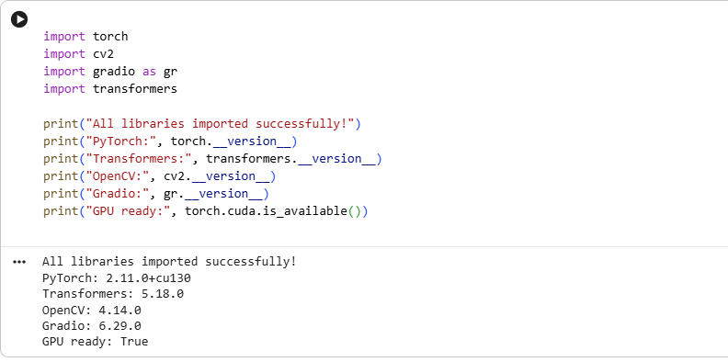

DEPARTMENT OF ROBOTICS & ARTIFICIAL INTELLIGENCE

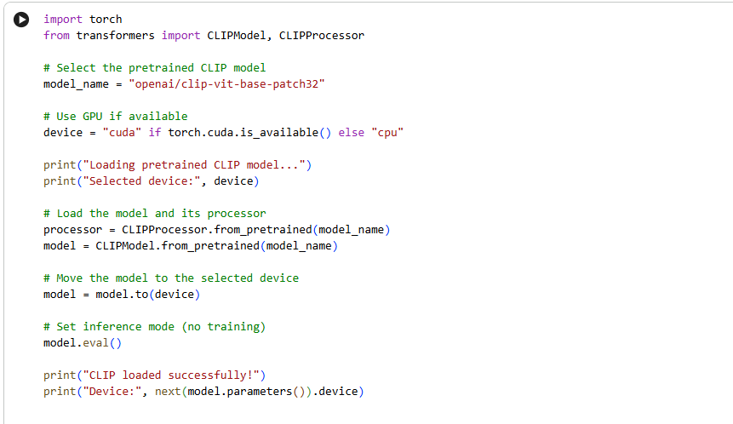
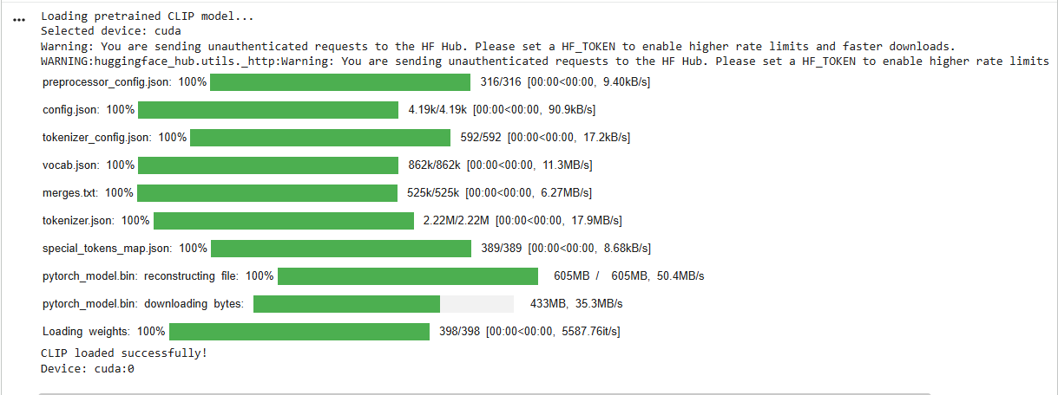

DEPARTMENT OF ROBOTICS & ARTIFICIAL INTELLIGENCE

Video upload and frame extraction

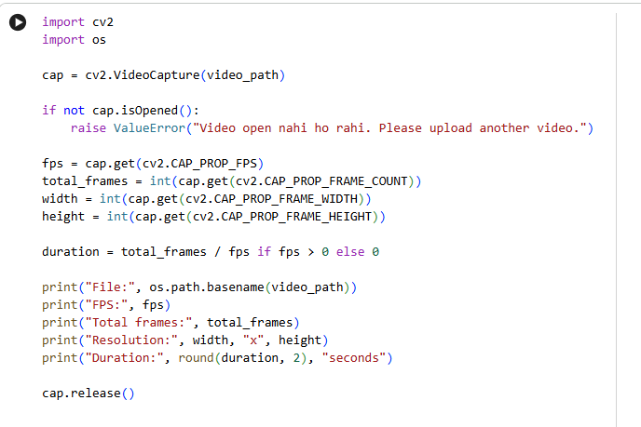
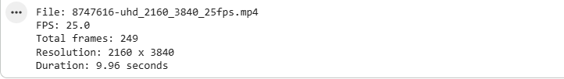
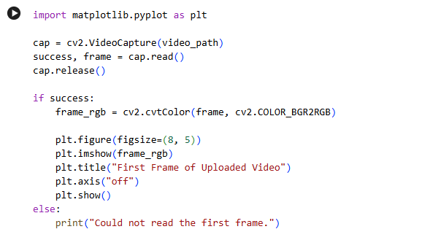

DEPARTMENT OF ROBOTICS & ARTIFICIAL INTELLIGENCE

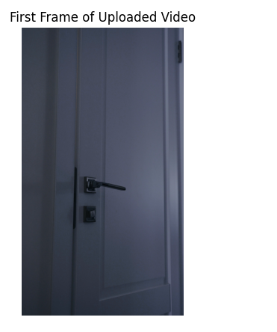
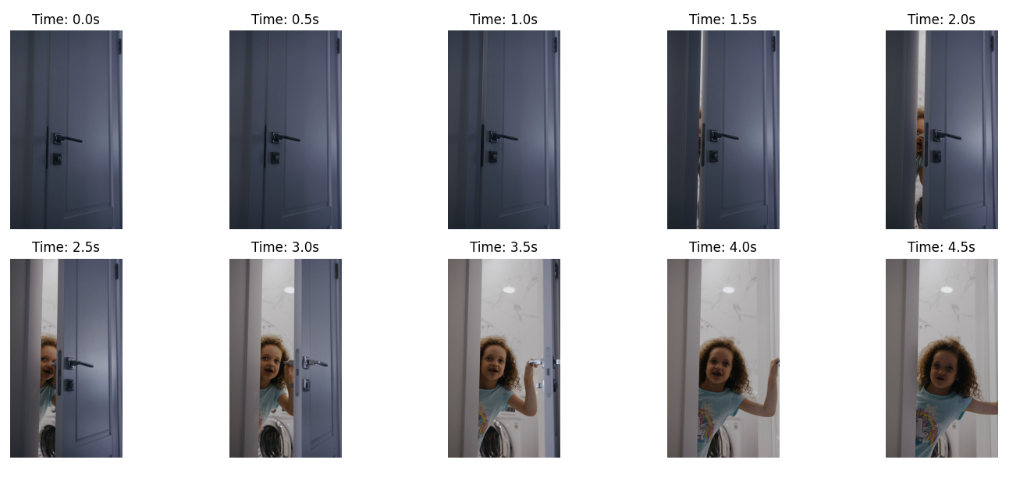

DEPARTMENT OF ROBOTICS & ARTIFICIAL INTELLIGENCE

Blur detection

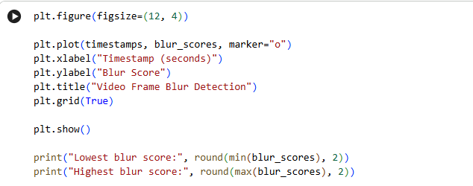

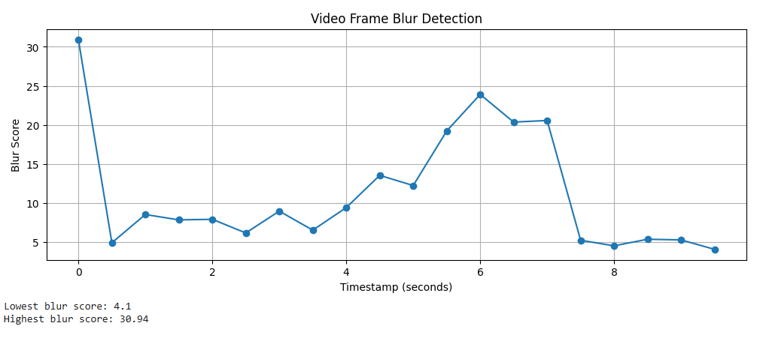

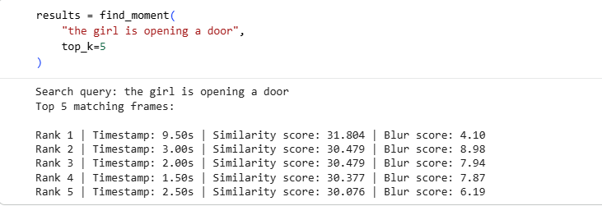

DEPARTMENT OF ROBOTICS & ARTIFICIAL INTELLIGENCE

Natural-language matching and ranking

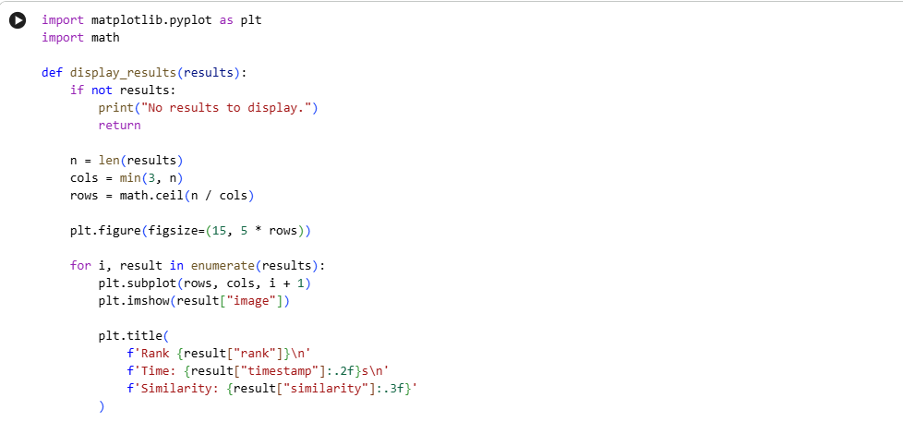
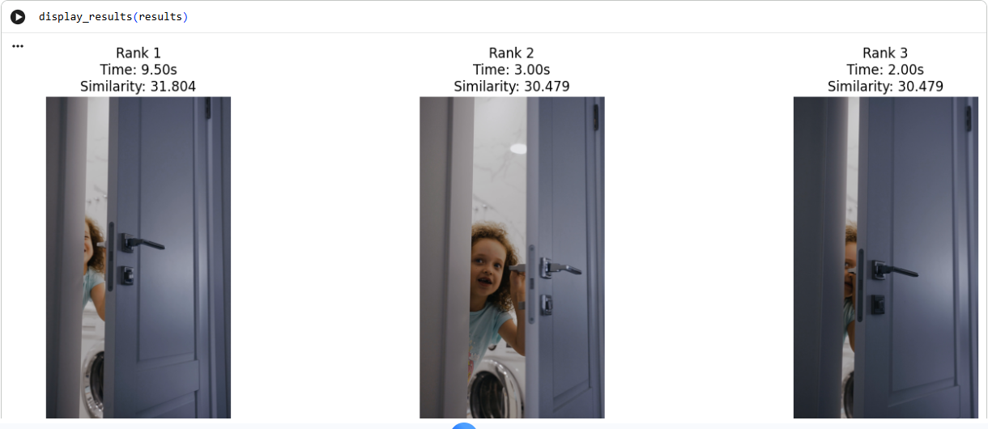

DEPARTMENT OF ROBOTICS & ARTIFICIAL INTELLIGENCE

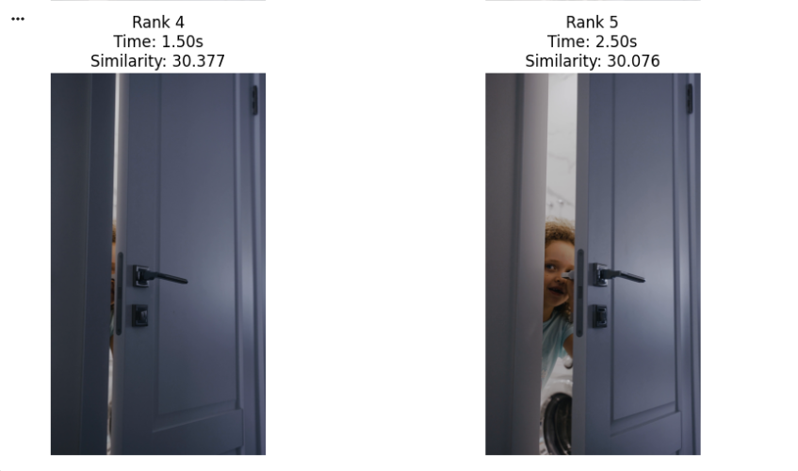

Flask backend

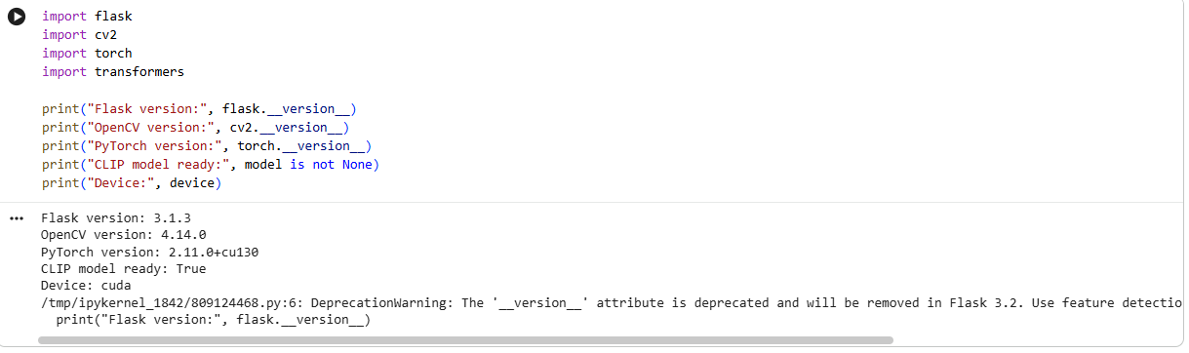

DEPARTMENT OF ROBOTICS & ARTIFICIAL INTELLIGENCE

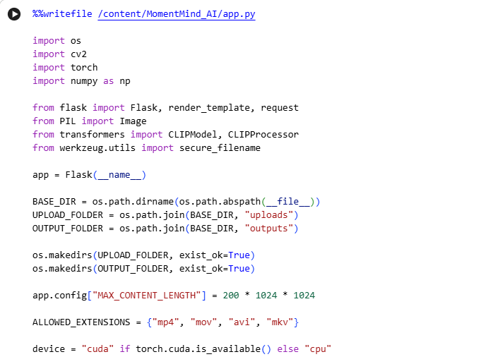

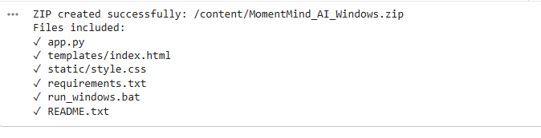

DEPARTMENT OF ROBOTICS & ARTIFICIAL INTELLIGENCE

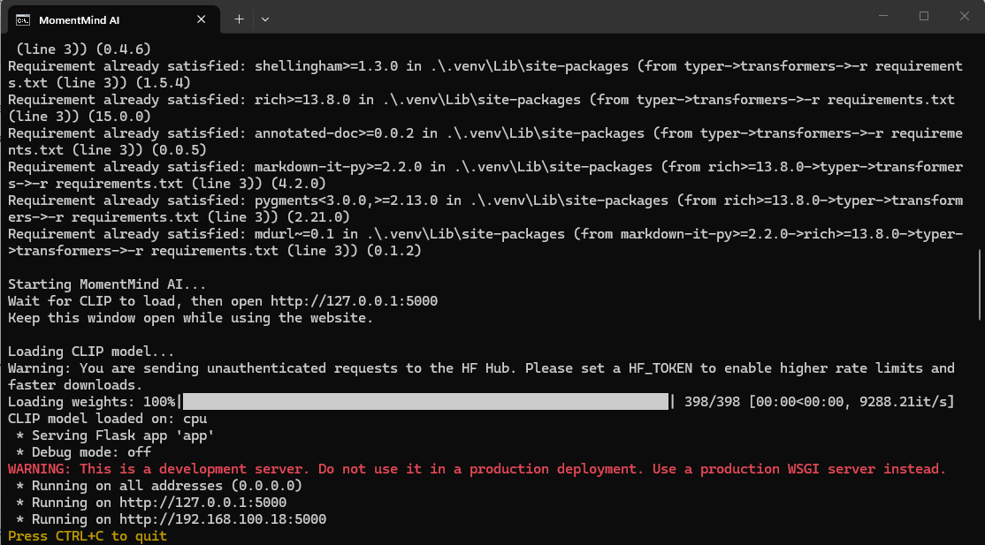

10. Moment Mind AI Homepage and Video Upload Interface

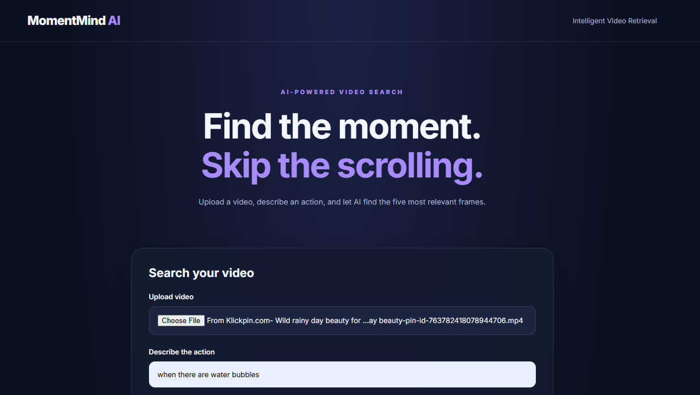

DEPARTMENT OF ROBOTICS & ARTIFICIAL INTELLIGENCE

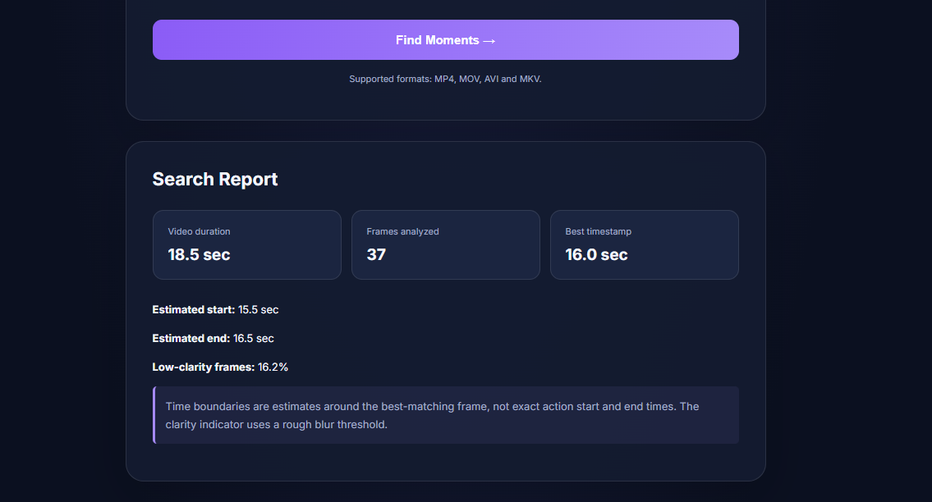
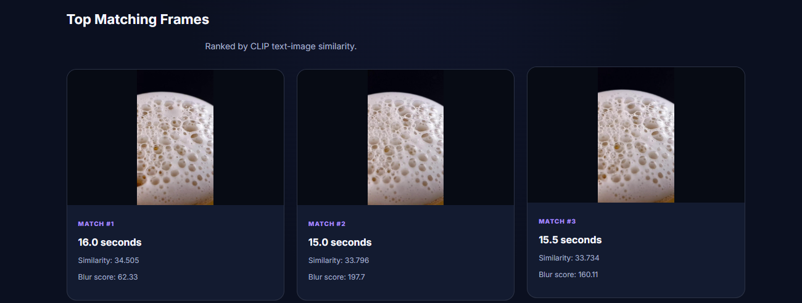
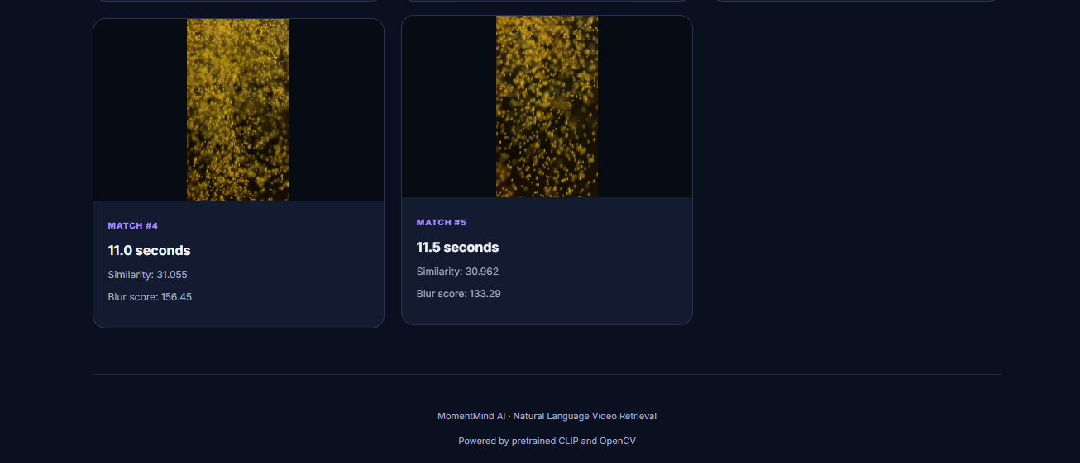

DEPARTMENT OF ROBOTICS & ARTIFICIAL INTELLIGENCE

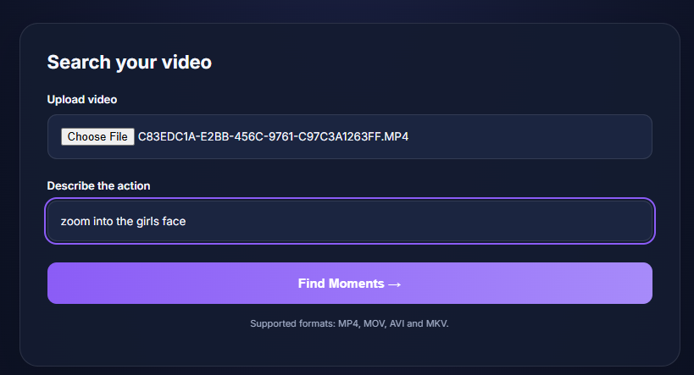
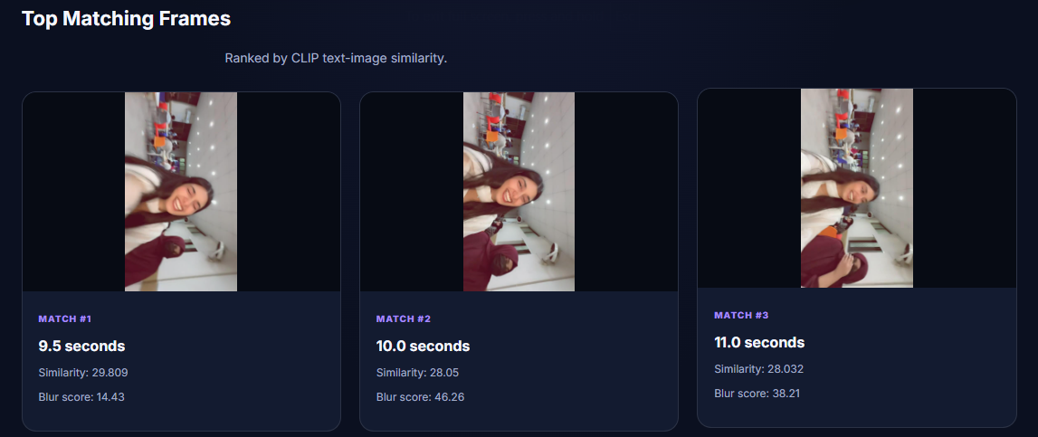
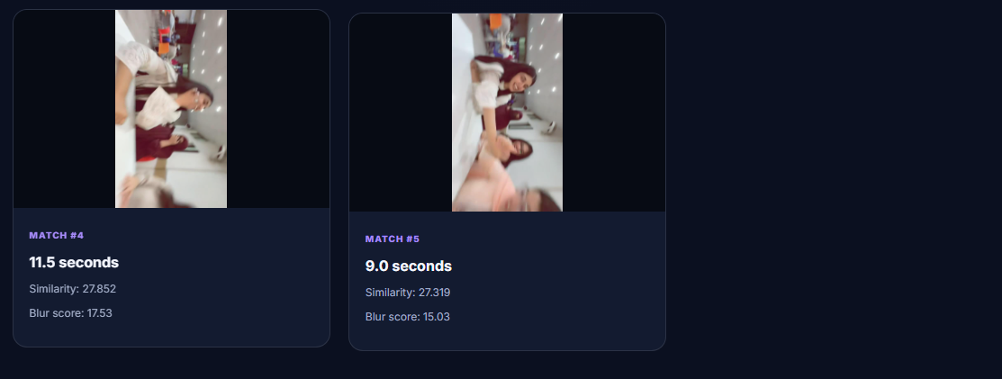

DEPARTMENT OF ROBOTICS & ARTIFICIAL INTELLIGENCE

GitHub Repository Link:

https://github.com/jalishakhalid12-bit/MOMENT-MIND-AI-PROJECT-REPORT-24108209-

